BB Regression

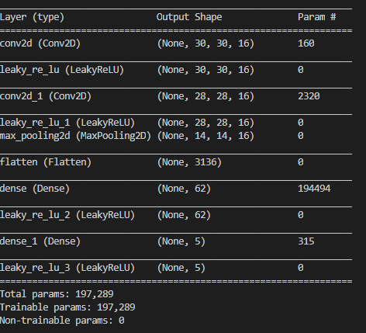

IoU 0.8966

~2.3mb

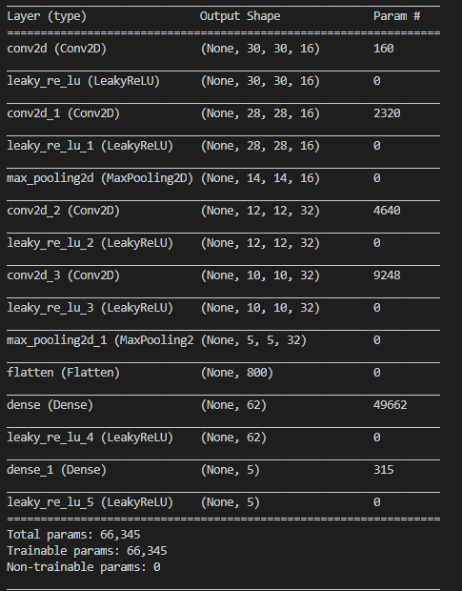

IoU 0.9073

~638kb

Add 2 more conv, 1 maxpool

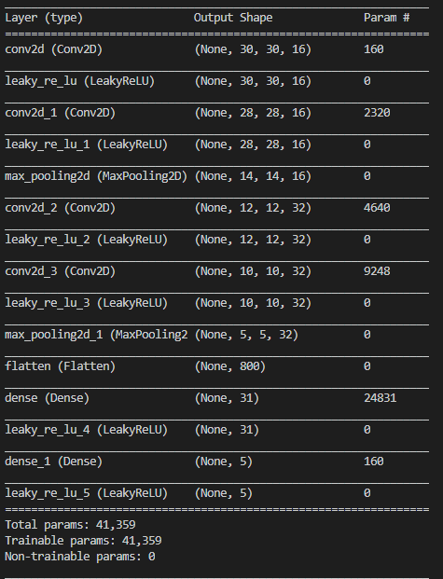

IoU 0.9050

539kb

Reduce half dense layer nodes

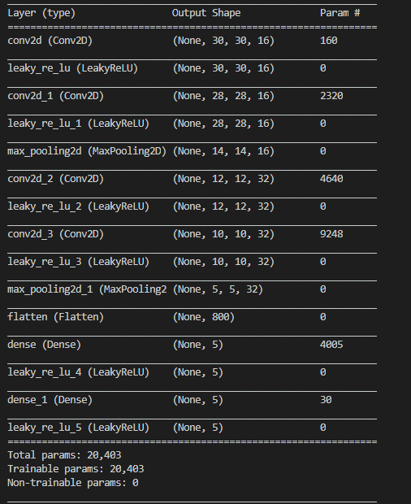

Iou 0.9058

293kb

Reduce dense node to 5

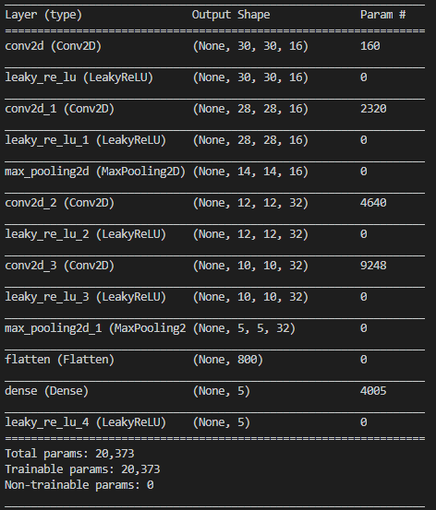

Remove 1 dense layer

Iou 0.8987

288kb

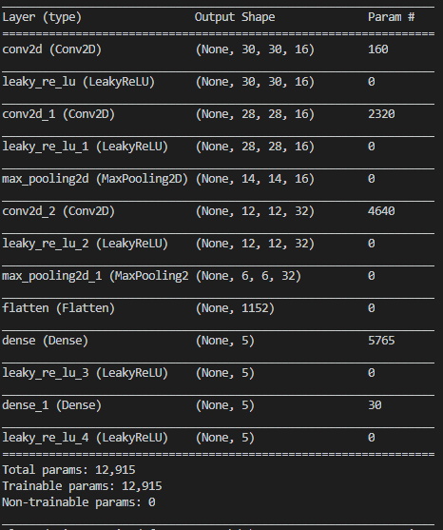

added dense layer with 5 nodes, removed one conv layer (32ch)

iou 0.9006

200kb

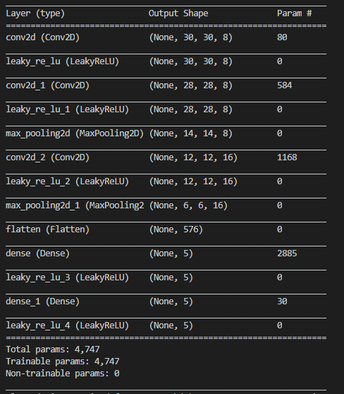

Reduce channels of all conv by half

Iou 0.8945

103kb

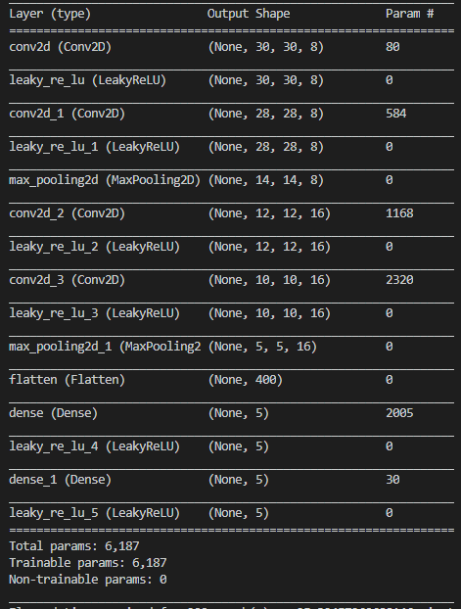

Add conv layer (16)

IoU 0.9031

126kb

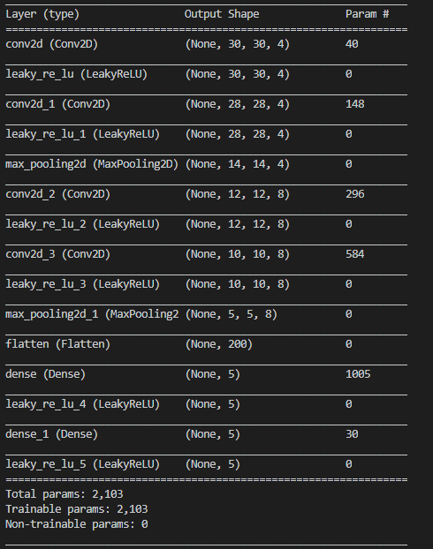

Halve all conv layer

IoU 0.8761

80kb

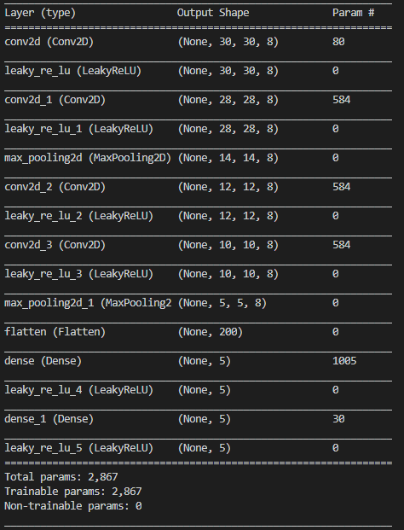

Restore first 2 conv layers to 8ch, keep last 2 conv layer same (all 8ch)

IoU 0.8691

87kb

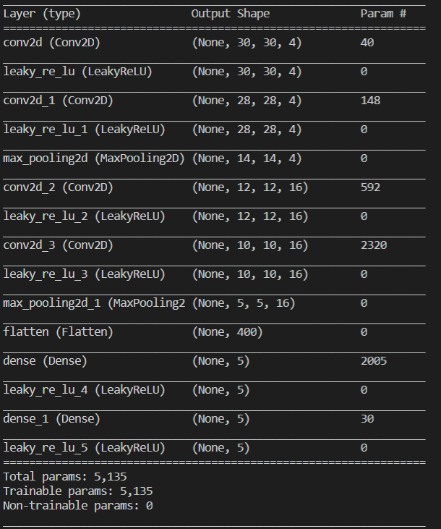

Halve first 2, double last 2 conv

IoU 0.8957

114kb

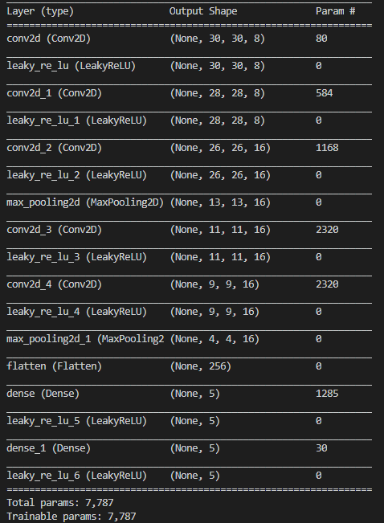

Add one more conv layer